

**Course: Post Graduate Diploma in Water, Sanitation and Hygiene Promotion - Assignment number 7**

**Student Number: AIPMS/122/2018**

**Submitted by Henry Ilunga Kasongo Kelakazola, 31th  December 2018**

Assignment

1. Explain 5 reasons why emergencies can put people at greater risk of waterborne disease.
2. Sustainability is essential in any project. Substantiate this claim. How is sustainability achieved in donor funded projects? Explain 3 aspects
3. How would you explain what advocacy means to a colleague who is not a WASH worker? Explain the difference between policy advocacy and programme advocacy.
4. Outline four particular challenges involved in urban WASH advocacy.
5. What do you understand by community mobilization? Describe briefly how it can be achieved.

b). Explain why knowing your community is essential for effective community mobilization.

1. **Explain 5 reasons why emergencies can put people at greater risk of waterborne disease.**

Emergency situations can arise as a result of disease outbreaks, natural disasters or man-made incidents. Contamination of water sources or distribution systems by disease-causing micro-organisms is a common cause of widespread disease outbreaks, leading to emergency in urban areas. Contamination at the source, or along the pipe network where there are leakages, can reach a large number of people very quickly. Piped-water systems are more likely to become contaminated when pipes are allowed to become empty, either as a result of the common practice of rationing water distribution or because the supply has dried up. This is because the pressure goes down in empty pipes, which can lead to contaminated water seeping in through defects in the pipe (AIPMS, 2018).

Floods are another common cause of emergency situations in urban areas. When extreme rainfall occurs, the run-off generated can exceed the capacity of the town’s drainage systems. Accumulated solid wastes may have already piled up in the canals, reducing their water carrying capacity. As a result, flood water can overflow into streets and houses and, as this happens, harmful bacteria living and reproducing in the waste are also transported to households (AIPMS, 2018)..

Because of emergency, there may be limited or no access to sanitation facilities., thus people can resolt to open defecation and also can defecate in source of water such as surface water. In communities that practise open defecation, excreta may be carried with the flood water to contaminate the surrounding neighbourhood. The floods can also cause pit latrines and septic tanks to overflow causing further contamination. In addition, peri-urban and rural communities living downstream of the urban area are threatened because the flood eventually transports contaminants to these areas. The risk may be even higher here, especially if these communities depend on river water for their daily needs (AIPMS, 2018).

We cannot control natural incidents, such as rains and floods. However, we can control how we choose to live our lives in order to reduce health risks. Individuals and communities are responsible for stopping bad practices, such as open defecation, and adopting safe practices such as using latrines and handwashing. Communities are sometimes reluctant to use safe practices and, in urban areas, due to their mixed and diverse characteristics and a poor sense of belonging, this reluctance can be particularly pronounced (AIPMS, 2018).

The WASH service providers (e.g. water utilities), in collaboration with communities, must be alert to continuously ensure water safety from source to use. Routine activities to ensure this can include water source protection, distribution system inspection and maintenance, and monitoring the efficiency of water treatment facilities (AIPMS, 2018).

However, it is not always possible to ensure complete safety at source for technical or operational reasons. Therefore **household water treatment** (HWT) options, using chemicals or other alternatives, are widely recommended as a means to ensure water safety at point-of-use. Even if water arriving at users’ homes is contaminated, using household treatment options (also known as point-of-use treatment) should guarantee 100% safety if instructions are followed correctly. During emergencies these chemical treatments serve a very important and lifesaving role, and are usually distributed in tablet or powder forms to affected communities (Figure 1.8) (AIPMS, 2018).

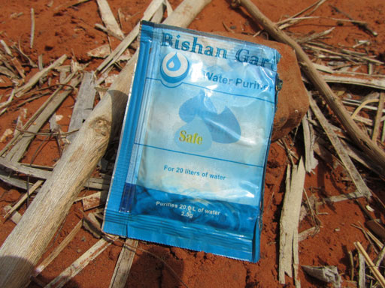

*Figure 1 Water treatment sachets may be distributed in emergency situations.*

In such emergency situations, slum areas are particularly prone to being affected, owing to their lack of infrastructure. Vulnerable groups may be more seriously affected by the lack of WASH services than other users, so emergency interventions should provide inclusive solutions to assist vulnerable people such as children, the elderly and the disabled, alongside the plan for the wider community (AIPMS, 2018).

1. **Sustainability is essential in any project. Substantiate this claim. How is sustainability achieved in donor funded projects? Explain 3 aspects**

Sustainability in the context of sustainable development is defined by the World Commission on Environment and Development (1987) as ‘forms of progress that meet the needs of the present without compromising the ability of future generations to meet their needs’. This broad definition emphasises the aspect of future orientation as a basic element of sustainability. This care for the future implies, among other things, a wise use of natural resources and other aspects regarding the environmental footprint. The ‘green’ aspect of sustainability is recognised in many other definitions of sustainability. For example the OECD (1990) states that ‘the sustainable development concept constitutes a further elaboration of the close links between economic activity and the conservation of environmental resources. It implies a partnership between the environment and the economy.’

Other authors emphasise sustainability in relation to the development of underdeveloped regions. For example, Barbier (1987) links sustainable development to ‘increasing the material standard of living of the poor at the “grassroots” level, which can be quantitatively measured in terms of increased food, real income, educational services, healthcare, sanitation and water supply, emergency stocks of food and cash, etc.’

The combination of both social and environmental perspectives can be found in the earlier-mentioned report by the United Nations World Commission on Environment and Development (1987). The report states that, ‘in its broadest sense, sustainable development strategy aims at promoting harmony among human beings and between humanity and nature’.

The International Institute for Sustainable Development (2010) elaborates on the generic definitions in a definition more focused on sustainable management of organisations: ‘Adopting business strategies and activities that meet the needs of the enterprise and its stakeholders today while protecting, sustaining and enhancing the human and natural resources that will be needed in the future.’ Important in this definition is the mentioning of the ‘needs of the enterprise and its stakeholders today’. This aspect recognises that without profitability today, care for the environment and humanity cannot be sustained. John Elkington (1997), in his book *Cannibals with Forks: the Triple Bottom Line of 21st Century Business*, identified this as the ‘triple bottom line’ or ‘Triple-P (People, Planet, Profit)’ concept: Sustainability is about the balance or harmony between economic sustainability, social sustainability and environmental sustainability.

From the literature and definitions mentioned above, three key elements of sustainability can be identified (Dyllick and Hockerts 2002).

• Sustainability is about integrating economic, environmental and social aspects.

• Sustainability is about integrating short-term and long-term aspects.

• Sustainability is about consuming the income and not the capital.

**Sustainability is about integrating economic, environmental and social aspects**

This element refers to the triple bottom line or three-P concept as stated by Elkington (1997) and acknowledged by Adams (2006) as the ‘three pillars’ of sustainability: Social, Environmental and Economic (illustrated in [Figure 11.1](http://books.publishing.monash.edu/apps/bookworm/view/The+Project+as+a+Social+System%3A+Asia-Pacific+Perspectives+on+Project+Management/171/OEBPS/c11.htm#fig11-1)). The concept suggests that three dimensions are inter-related and therefore may influence each other in multiple ways.

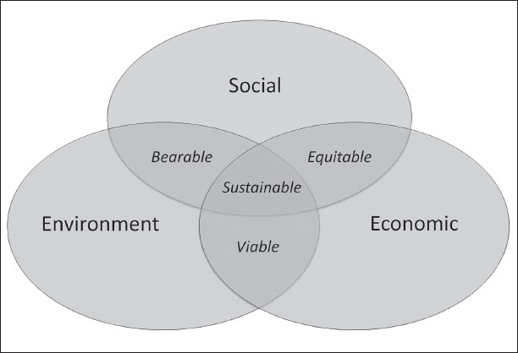

***Figure 2. The triple-P concept of sustainability***

**Sustainability is about integrating short-term and long-term aspects**

This element focuses attention on the long-term nature of the matter at hand. An important notion in this aspect is that the economic perspective, because of discount rates, tends to value short term effects more than long term effects, whereas social impacts or environmental degradation may not occur before the long-term.

**Sustainability is about consuming the income and not the capital**

This idea is common in business. From a social or environmental perspective, however, the impact may not be visible in the short-term, causing degradation of resources in the long run. Sustainability implies that ‘the natural capital remains intact. This means that the source and sink functions of the environment should not be degraded. Therefore, the extraction of renewable resources should not exceed the rate at which they are renewed, and the absorptive capacity of the environment to assimilate waste, should not be exceeded’ (Gilbert et al. 1996).

**Sustainability in project management**

The concerns about sustainability indicate that the current way of producing, organising, consuming, living, etc. may have negative effects on the future. In short, our current way of ‘doing things’ is not sustainable. Therefore, some ‘things’ have to change. And since change in organisations, whether it is a new production plant, a new product, a new business process or a new resource, is in many cases organised as projects (Silvius and Batenburg 2009), it can be concluded that a (more) sustainable society requires projects. In fact, this connection between sustainability and projects was already established by the World Commission on Environment and Development (1987). However, Eid (2009) concludes two decades later that the standards for project management ‘fail to seriously address the sustainability agenda’.

When discussing the implications of sustainability for project management, it is of eminent importance to have a clear understanding of the elements of sustainability outlined above. This may be a challenging exercise because the elements are conceptual, rather than practical (Moneva et al. 2006; Pope et al. 2004). The concept of sustainability is understood intuitively, but is not easily expressed in concrete operational terms (Briassoulis 2001). The relationship between sustainability and project management is still an emerging field of study. Literature is scarce, but some first studies and ideas were published in recent years. An overview of publications is provided in [Table 11.1](http://books.publishing.monash.edu/apps/bookworm/view/The+Project+as+a+Social+System%3A+Asia-Pacific+Perspectives+on+Project+Management/171/OEBPS/c11.htm#tab11-1).

Some of the studies listed in this table (Labuschagne and Brent 2006; Association for Project Management 2006; Russell 2008) focus on the implications of sustainability for business strategy and policies and thereby on the *content* of projects/changes. More specifically, they focus on the considerations that should be taken into account in defining or managing projects. The studies pay little attention to the implications of sustainability on project management processes and on the competencies of the project manager.

Other studies (Eid 2009; Gareis et al. 2009; Turner & Huemann 2010) focus on the impact of sustainability on the *process* of managing projects/changes. These studies tend to pay little attention to the contribution of projects and project management to sustainability.

In our work (Silvius et al. 2009; 2010) we try to cover both the content aspect of sustainability as well as the process aspect. Based on the studies mentioned in [Table 11.1](http://books.publishing.monash.edu/apps/bookworm/view/The+Project+as+a+Social+System%3A+Asia-Pacific+Perspectives+on+Project+Management/171/OEBPS/c11.htm#tab11-1), the following insights on sustainability in project management can be derived.

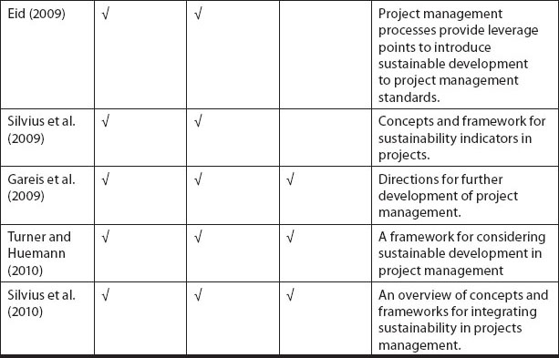

***Table 1. Studies on sustainability in project managemen***

**Sustainability in project management is about integrating economic, environmental and social aspects in the content and management of projects**

This insight corresponds with the triple bottom line element of sustainability. Integrating sustainability in project management requires the inclusion of ‘People’ and ‘Planet’ performance indicators in the management systems, formats and governance of projects (Silvius et al. 2009). In current project management methodologies, the management of projects is dominated by the ‘triple-constraint’ variables of time, cost and quality (Project Management Institute 2008). And although the success of projects is most often defined from a more holistic perspective (Thomas and Fernandéz 2007), this broader set of criteria doesn’t reflect on the way projects are managed.

The triple-constraint variables clearly put emphasis on the profit ‘P’. The social and environmental aspects may be included as aspects of the quality of the result, but they are bound to get less attention.

**Sustainability in project management is about considering the full life-cycle of the project**

Given the future-orientation of the concept of sustainability, a logical implication is to consider the full life-cycle of a project, from its conception to its disposal. This view is further developed by Labuschagne and Brent (2006). In their work they argue that when considering sustainability in project management the total life cycle of the project (e.g. initiation-development-execution-testing-launch) should be taken into account. But not just the life-cycle of the project is relevant. The project will ‘produce’ a result, being a change in assets, systems, behaviour, etc. The asset produced should also be considered over its full life cycle. And the life cycle of the product or service that the asset produces should be considered. [Figure 11.2](http://books.publishing.monash.edu/apps/bookworm/view/The+Project+as+a+Social+System%3A+Asia-Pacific+Perspectives+on+Project+Management/171/OEBPS/c11.htm#fig11-2) visualises how these life cycles, ‘project life cycle’, ‘asset life cycle’ and ‘product life cycle’, interact and relate to each other. Including sustainability considerations in projects suggests that these three life cycles need to be taken into account.

Because Labuschagne and Brent (2006) include the result of the project in their framework, it is sensitive to the context of the project. Their studies focus on the manufacturing sector in which projects generally realise assets that produce products. In other contexts, the result of a project may not be an asset, but an organisational change or a new policy. The general insight, however, is that sustainability in projects should be considered in relation to results and effect.

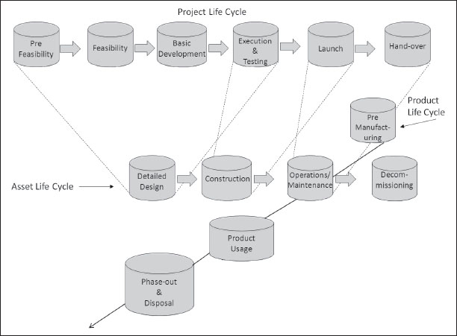

**Figure 3. Interrelating life-cycles (based on Labuschagne & Brent 2006)**

Combining the triple-P element of sustainability and the life-cycle views, the following definition of sustainable project management can be derived: Sustainable Project Management is the management of project-organised change in policies, assets or organisations, with consideration of the economic, social and environmental impact of the project, its result and its effect, for now and future generations.

**Implications**

The implications of integrating sustainability into project management can be grouped into a number of fields. We identify:

• the impact of sustainability on project management processes;

• the impact of sustainability on measuring, reporting and governing projects;

• the impact of sustainability on project management competencies.

**The impact of sustainability on project management processes**

This section explores how sustainability could be included in the familiar process standards of project management and what the impact could be. We will consider the inclusion of sustainability in the Project Management Institute’s (2008) *A Guide to Project Management Body of Knowledge (PMBOK Guide)*. Since the ‘profit’ aspects of sustainability are traditionally addressed in the triple constraint of project management, cost, time and quality, we will focus this analysis on the social and environmental aspects of sustainability.

For the purpose of this paper, the fourth edition of the *PMBOK Guide* (Project Management Institute 2008) was studied for aspects of sustainability. Both the Index and the Glossary do not mention sustainability as a relevant word or term. Also in parts of the guide where a reference to sustainability aspects would be quite logical, this reference is not made. For example Paragraph 1.8, Enterprise Environmental Factors, mentions the organisation’s human resources and marketplace conditions as ‘internal or external environmental factors that surround or influence a project’s success’. But the paragraph fails to more explicitly identify potential social or environmental elements resulting from sustainability policies as factors of influence.

Also, in relation to ‘stakeholders’, any reference to typical sustainability stakeholders such as environmental protection pressure groups, human rights groups or non-governmental organisations are lacking. In fact, [Chapter 10](http://books.publishing.monash.edu/apps/bookworm/view/The+Project+as+a+Social+System%3A+Asia-Pacific+Perspectives+on+Project+Management/171/OEBPS/c10.htm), ‘Project Communications Management’, also fails to recognise these potential stakeholders when it discusses stakeholder communication.

In the introduction of [Chapter 3](http://books.publishing.monash.edu/apps/bookworm/view/The+Project+as+a+Social+System%3A+Asia-Pacific+Perspectives+on+Project+Management/171/OEBPS/c03.htm), ‘Project Management Processes’, the *PMBOK Guide* mentions a few criteria for a successful project. Here it is mentioned that the project manager should be able to ‘balance the competing demands of scope, time, cost, quality, resources and risk’ (Project Management Institute 2008). In this section the PMBOK Guide fails to recognise social and environmental aspects as relevant factors in project success.

Also in [Chapter 11](http://books.publishing.monash.edu/apps/bookworm/view/The+Project+as+a+Social+System%3A+Asia-Pacific+Perspectives+on+Project+Management/171/OEBPS/c11.htm), ‘Project Risk Management’, there is no mentioning of ecological and/or social risks.

Does this mean that the *PMBOK Guide* has no eye for sustainability aspects at all? Well, we found two references to aspects of sustainability. One is surprisingly clear. Paragraph 4.1.1., Develop Project Charter, mentions ‘Ecological impacts’ and ‘Social needs’ as potential benefits of a project when it discussed the business case. The other reference is more implicit. The processes in the *PMBOK Guide*are derived from the generic project life cycle. In fact, it also mentions the interaction between the project life cycle and a product life cycle in paragraph 2.1.2. Product vs. Project Life Cycle Relationships.

Based on this analysis it can be concluded that the concepts of sustainability are not yet fully included in the project management processes in the *PMBOK Guide*. Obvious areas of impact should be the identification of stakeholders, the criteria for project success and the business case.

This analysis is confirmed by Eid (2009). In his study he asked 36 project management practitioners about their assessment of the impact of sustainable development on project management and on the area of impact. [Figure 11.3](http://books.publishing.monash.edu/apps/bookworm/view/The+Project+as+a+Social+System%3A+Asia-Pacific+Perspectives+on+Project+Management/171/OEBPS/c11.htm#fig11-3) shows that in all five of the project management process groups (Project Management Institute 2008), an impact from sustainability is expected.

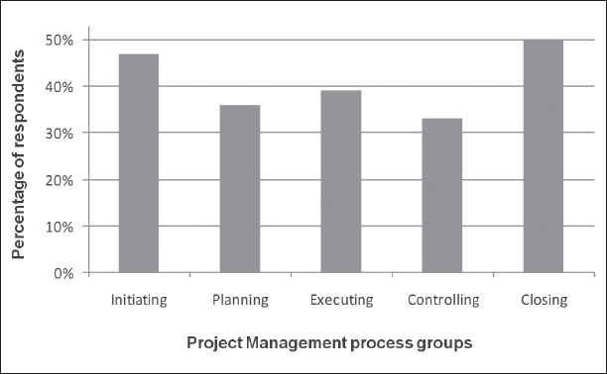

**Figure 4. The best areas to integrate sustainable development into project management (based on Eid 2009)**

**The impact of sustainability on measuring and reporting projects**

In considering the impact of sustainability on measuring and reporting projects, the conceptual concepts of sustainability should be translated into concrete indicators. An analysis of efforts to do so reveals different approaches to this ‘translation’. Various discussions form the basis for these different approaches.

One discussion is between monetary and physical indicators (Turnhout et al. 2007; Singh et al. 2009). Many economists argue that all the sustainable effects of the behaviour of a company or a project can be translated into monetary consequences (Coase 1960) The big advantage of this is that all different kind of indicators are expressed in the same way. Critics argue that this leads to an oversimplification of reality.

Another discussion focuses on the difference between biotic and abiotic indicators (Turnhout et al. 2007). Biotic indicators describe direct, biological consequences, e.g. the concentration of plankton in seawater, or the number of birds of prey in a certain area. Abiotic indicators are indirect indicators like the concentration of ozone or the level of pesticide pollution. Biotic indicators are often seen as the most valuable indicators. At the same time their numbers can fluctuate easily. Abiotic indicators are more stable but only measure whether the conditions for a good ecological system are present, not how this ecological system really ‘behaves’.

There is an ongoing academic debate about the approaches described above. This debate is fuelled by a lack of knowledge in many areas, specifically when it comes to discussions about the ‘planet’ indicators (Turnhout et al. 2007). Complex ecological systems are difficult to understand and even more difficult to capture in one or two indicators. According to various authors all these different approaches are not just signs of an intense scientific debate but also show the normative arguments that are part of the discussion. For example, what are the criteria to include or exclude certain indicators? (Niemeijer et al. 2008)

The most well-known set of sustainability indicators based on stakeholder participation is the Global Reporting Guidelines from the Global Reporting Initiative (GRI). The GRI is a set of criteria developed by a wide variety of different stakeholders. [Table 11.2](http://books.publishing.monash.edu/apps/bookworm/view/The+Project+as+a+Social+System%3A+Asia-Pacific+Perspectives+on+Project+Management/171/OEBPS/c11.htm#tab11-2) provides an overview of the GRI criteria.

The GRI is used by 1000 to 3000 organisations (Brown et al. 2009; GRI 2009) and it is still becoming more popular. One third of all sustainability reports of the largest 100 companies in various countries in the world are explicitly inspired by the GRI (Brown et al. 2009).

The implication of the goal of sustainability for project management is that this set of indicators is matched with the indicators on which a project is managed. The total set of indicators is probably far too extensive to use in most projects, but a selection of relevant indicators can be very useful for project managers to get a better understanding of the sustainability aspects of their project.

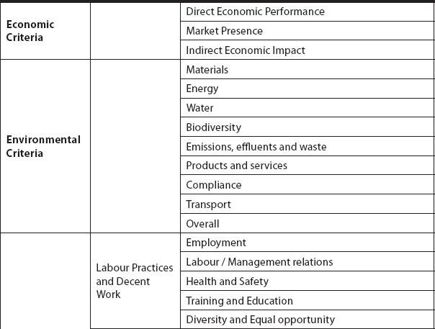

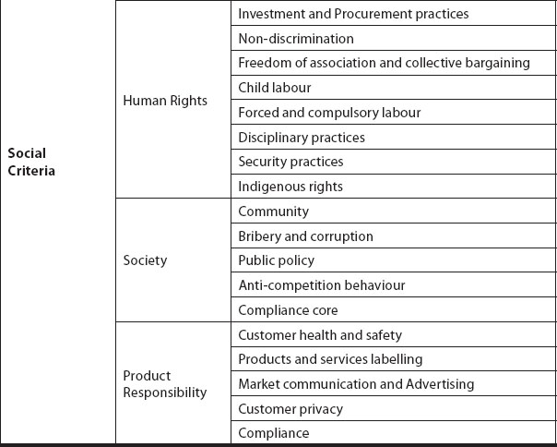

**Table 2. Overview of indicators in the Global Reporting Guidelines**

**The impact of sustainability on project management competencies**

This section explores how a concern for sustainability is included in the widely used standards for project management competencies, the International Project Management Association’s (IPMA) *Competence Baseline version 3* (ICB3). The ICB3 provides the official definition of the competences expected from project management personnel by the IPMA for certification using the universal IPMA certification system. It is the common framework document that all IPMA Member Associations and Certification Bodies abide by to ensure that consistent and harmonised standards are applied.

In ICB3, the IPMA added two new groups of competences to the baseline: behavioural and contextual. ICB3 now breaks professional project management down into 46 competences that cover the following categories (International Project Management Association 2006):

• technical competences for project management (20 competences);

• behavioural competences of project personnel (15 competences);

• contextual competences of projects, programs and portfolios (11 competences).

The word ‘sustainable’ is scarcely used in the ICB3 (International Project Management Association 2006): competence 2.04 Assertiveness talks about ‘sustainable relationships to the interested parties’ (p. 94) and competence 3.09 Health, Safety, Security, Environment talks about ‘security and sustainability’ (p. 32).

The content of sustainability, however, is addressed under the key word of ‘project context’. This starts in competence 1.3 Project Requirements & Objective, where the conformity to the context conditions is required in addition to achieving the project objectives. The context is later specified in several of the contextual competences: 3.05 Permanent Organisation; 3.06 Business; 3.07 Systems, Products & Technology; 3.08 Personnel management; 3.09 Health, Safety, Security, Environment.

In 3.07 Systems, Products & Technology and 3.09 Health, Safety, Security, Environment the subjects within sustainability (e.g. the systems life cycle management) are well addressed. Also the responsibility (permanent organisations) and some processes (e.g. internal and external audits) and tools (Environmental Impact Study) are mentioned. And the reference to ethics in competence 2.15 implies that at least some social aspects are taken into consideration. Other references to the social aspects of sustainability can be found in element 3.08 Personnel management and 2.14 Values appreciation.

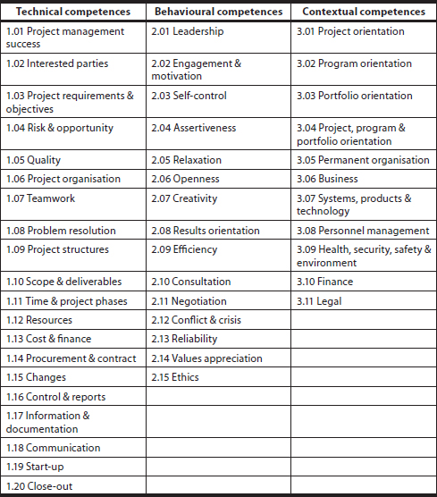

**Table 2. The project management competences from the ICB3**

Although our analysis shows that indications of and references to aspects of sustainability can be found, the full integration of sustainability in project management competences requires a further elaboration of the behavioural and contextual aspects of the ICB3.

As Eid (2009) concluded, ‘Project management … knowledge areas fall short of committing to a sustainable approach’.

**Conclusion**

Projects can make a contribution to the sustainable development of organisations. It should therefore be expected that the concepts of sustainability are reflected in projects and project management. And although some aspects of sustainability are found in the various standards of project management, it has to be concluded that the impact of sustainability is not fully recognised yet. The standards of project management do not completely reflect the different aspects of sustainability that can be derived from the concepts of sustainable development.

Based on the concepts of sustainability, we developed a working definition of Sustainable Project Management:

Sustainable Project Management is the management of project-organised change in policies, assets or organisations, with consideration of the economic, social and environmental impact of the project, its result and its effect, for now and future generations.

This view of Sustainable Project Management suggests a number of areas in which project management needs to develop further in order to capture the impacts of sustainability planning. These areas are:

• project management processes;

• project management performance indicators;

• project management competencies.

These areas of impact also hold a recommendation for further research.

We suggest the development of a framework that can be used to identify the sustainability aspects and criteria of projects. In this framework the people-planet-profit concept of sustainability should be recognised in such a way that projects can be considered on criteria of ‘social sustainability’, ‘environmental sustainability’ and ‘economic sustainability’. These criteria or indicators should then be applied on the level of the project itself, and impact on its result (an asset, product or a change) and its effect (what is it that the asset delivers).

It is clear that there is still a lot of work to be done on the implications of Sustainable Project Management and that there is a growing need for expertise, criteria and concepts to practically implement the concept in the management of projects. The consequences are not at all clear yet and may even be underestimated. The definition we developed, however, provides a foundation for further development and operationalisation.

1. **How would you explain what advocacy means to a colleague who is not a WASH worker? Explain the difference between policy advocacy and programme advocacy.**

Advocacy means making a case in support of a particular cause or activity and trying to convince other people that it is a good idea. It is a process of gathering and organising information to be communicated to decision makers in an attempt to influence decisions (Open University, 2018).

Advocacy aims to influence decision makers at various levels – at federal, regional, woreda and local levels. Advocacy for WASH may, for example, try to raise funds and other resources or get support for a particular project from political and social leaders (Open University, 2018).

It means making a case in support of a particular cause or activity and trying to convince other people, usually decision makers, that it is agood idea. Advocacyis a process to influence decisions within political, economic and social systems and institutions. In an urban WASH context, advocacy may include many activities that you and your organisation undertake including engaging opinion leaders, addressing community meetings, media campaigns and public speaking (Open University, 2018).

In general, advocacy approaches are either directed towards policies or towards programmes. **Policy advocacy** involves attempts to explain to senior politicians and administrators the impact of an issue at the national level and the need for changes to laws and policies (WHO, 2008). In a WASH context, an example is a media campaign to advocate a decrease in the tax imposed on soap to help improve use of soap. **Programme advocacy** takes place at a more local level. It involves attempts to explain to local leaders the need for action at local community level. In an urban WASH context this might include the mobilising of community leaders to promote the practice of handwashing or mobilising religious leaders to interpret and explain faith-based texts which refer to the importance of personal hygiene (Open University, 2018).

Advocacy for improving urban WASH services involves organising public opinion and participation to make changes in policy and practice as well as influencing policy makers and implementers to consider community interests. It can involve a range of strategies and activities that are intended to draw attention to an issue. Various materials and media can be used to communicate WASH information, not only posters and pamphlets but other options such as spoken messages or T-shirts, as shown in Figure 5.



*Figure 5 These T-shirts have been printed with information about a community outreach programme.*

Advocacy should be strategic and use well-designed and organised activities to influence policy or decision makers about the important issues that you think will affect the water supply, sanitation and hygiene of your community. For instance urban WASH policy, legislation and regulations may be in place but might not be applied. As a WASH practitioner you could identify these gaps and advocate the use of existing structures and mechanisms to try to close them (Open University, 2018).

1. **Outline four particular challenges involved in urban WASH advocacy.**

Supporting local and national networks to influence those who create policies, laws, regulations and budgets may present significant challenges. Belonging to a network can take up a lot of time and many of the activities involved are complex and difficult to achieve. These challenging activities could include:

* training communities (Figure 12.5), community leaders, other network members and local waterboards and associations on their rights and responsibilities regarding urban WASH laws, budgets and policies
* educating national and local political leaders on urban WASH
* strengthening policy dialogues between communities, civil society groups and decision makers
* urging increased funding for government-funded urban WASH programmes
* supporting high-quality urban WASH messaging in local news media etc. may require more time and resources ( Open University, 2018).

1. **What do you understand by community mobilization? Describe briefly how it can be achieved.**

**Introduction**

Community mobilization is based on the simple premise that human beings are by nature social creatures whose behaviors, attitudes and beliefs are profoundly affected by the norms of the communities in which they live. It is the process of engaging communities to change the norms within their own communities. By its very nature it tends to be a primary level intervention. Its goal is to engage the community itself in activities that can prevent incidents of sexual and domestic violence (Lydia , 2011).

Keep in mind:

* Its purpose is not to educate communities, although communities will learn throughout the process.
* Its purpose is not to provide services to communities, although communities may develop strategies that include providing support to survivors.
* Its purpose is not to provide services to communities, although communities may develop strategies that include providing support to survivors (Lydia , 2011)..

**The purpose of community mobilization is to empower communities to recognize and change the existing norms relating to sexual assault and domestic violence.**

Community mobilization is a systemic effort that engages a community:

* to define the issue of sexual assault and/or domestic violence;
* to recruit recruiting stakeholders, champions, and leaders
* to initiate and/or sustain change efforts;
* to develop a plan to prevent the violence as it occurs specifically in their community; and
* to implement their plan (Lydia , 2011)**.**

As professionals, our role is facilitating this process. For many people working in sexual and domestic violence programs, the most difficult task in incorporating community mobilization into prevention work is adopting the mentor and facilitator role. We have a tendency to do the work ourselves, rather than engage the community. Making this shift can be a challenge. A community mobilization strategy requires a significant investment in time and resources if you are to serve as an effective mentor and facilitator. It is most effective in communities that display a readiness to address the issues of sexual assault and domestic violence. Before engaging in an initiative, assess your resources and be aware of the possible benefits, challenges and common mistakes. Also take stock of your own comfort level with the role of facilitator and mentor and get training and mentoring if you feel it’s needed (Lydia , 2011).

**Benefits of Community Mobilization**

* It naturally works toward primary prevention.
* It is by definition community specific.
* It encourages community buy-in.
* It is a facilitative process (Lydia , 2011).

All communities have both community and cultural norms. Culture is the way of life of a particular society or group of people, including patterns of thought, beliefs, behavior, customs, traditions, rituals, dress, and language, as well as art, music, and literature. Community mobilization encourages stakeholders to develop and implement strategies that reflect the culture of the given community. When this happens, community mobilization initiatives become powerful tools in developing strategies that are culturally competent, relevant and compelling for historically marginalized communities (Lydia , 2011).

Many historically marginalized communities experience a sense of disconnection from mainstream institutions. There has been an expectation that universal strategies are enough, the one size fits all concept. As a field, we have not invested enough resources in the development and implementation of strategies that address the reality of the intersection between oppression of all types and its violence against women work. With community mobilization as a framework, communities can begin to understand oppression as part of the analysis of sexual and domestic violence and from there develop strategies appropriate within a specific community. Community mobilization can also leverage the rich history of culturally-specific strengths and assets (Lydia , 2011).

**Challenges of Community Mobilization**

* It requires significant initial investment of resources and relationship building.
* Because the strategy is process oriented, it is difficult to implement effectively within highly prescriptive environments.
* Community mobilization is a mix of structure and the unknown, making it a challenge to manage. While the aim is a standardized process, by definition the outcomes, outputs and activities will vary by community.
* It is a facilitative process and not a directive process (Lydia , 2011).

**Steps to Take - How to get started**

1. Establish a relationship with a community

2. Identify and recruit stakeholders

3. Gather stakeholders together into a Mobilization Team

4. Engage your Mobilization Team in developing a plan:

a. an asset mapping and/or community assessment process

b. developing an analysis of sexual and/or domestic violence

c. developing a community mobilization plan

d. developing an evaluation plan

5. Engage your Mobilization Team in implimenting the plan:

a. implementing a community mobilization plan

b. cultivating/maintaining assets

c. evaluating progress

d. assuming leadership roles in the mobilization process

e. developing a sustainability plan

6. Facilitate transfer of leadership of initiative to Mobilization Team

There are many specific community develop frameworks that can be implemented. Adaptations of frameworks by by the Asset Based Community Development Institute and William Lofquist have been used in violence against women community mobilization work, but there are many to choose from. Some frameworks lend themselves better to geographically-based communities, while others work better in communities bound together by other shared traits. What is most important is that you choose a framework that resonates for you and that you are prepared to engage in authentic power sharing (Lydia , 2011).

Community mobilization is all about relationships. To provide an initiative with the best chance for success you must have an existing positive relationship with a community that has a medium to high degree of readiness to address the sexual and/or domestic violence happening in its midst (Lydia , 2011).

**Common Mistakes**

* Most, if not all, community mobilization efforts will encounter prescribed structures that place limitations on some of the strategies that the group can realistically implement.
* Not understanding or acknowledging prescriptive parameters can be a costly mistake.
* Not trusting the wisdom of the group and/or allowing them to self-correct. Not identifying the correct stakeholders and/or being willing to add new stakeholders when they are identified.
* Misjudging community readiness.
* Not allowing enough time; community mobilizing is a time-intensive strategy.
* Not being committed to the entire process, in which the means are as important as the end (Lydia , 2011).

Community mobilization can be a wonderful strategy, providing you have a good knowledge of the dynamics of sexual and/or domestic violence, facilitation skills, community mobilization theory and a true affinity for the communities you are attempting to mobilize (Lydia , 2011).

Those who promote positive change most effectively are not those who provide a new set of answers, but those who allow a new set of questions (Lydia , 2011).

**Connecting Community Mobilization to the Social-Ecological Model of Prevention**

Community mobilization has the potential to impact all levels of the social-ecological model, even as the community level will be the designated or primary focus. As stakeholders engage in the mobilization efforts, the individual and relationship levels are impacted. Successful projects will change community norms regarding sexual assault and domestic violence. Community norms and societal norms regarding violence against women are deeply intertwined; as community norms shift the larger societal norms will also shift (Lydia , 2011).

**b). Explain why knowing your community is essential for effective community mobilization.**

Community mobilisation has much in common with community engagement in that it is about participation of community members. However, ‘mobilisation’ places the emphasis on actions. ‘Mobilising’ means getting things moving. Community mobilisation also has much in common with social mobilisation but has a more specific focus on communities. Social mobilisation was defined in Study Session 9 as a process enabling people to organise themselves to act collectively to achieve desired goals (WHO, 2006).

**Community mobilisation** can be defined as the process in which members of a community act together to achieve desired community goals. The process involves the community identifying their own needs and priorities, devising solutions and taking action to make changes happen.

Mobilisation empowers the community and enhances their ability to act together. The process involves facilitators whose role is to ensure that the community take the lead in the process. If essential WASH services are to be made available to every household in Ethiopia, communities should be mobilised and technically supported to identify their own WASH issues. Sustained mobilisation takes place when communities remain active and empowered after a particular community mobilisation programme ends (Mercy Corps, 2013).

Community mobilisation is a capacity building process, through which individuals, families, groups and organisations plan, implement and evaluate activities on a participatory and sustained basis to achieve an agreed goal. This might be a goal they have set themselves or a goal set by others. Figures 6 shows community members in discussion during such a process (Open University, 2018).

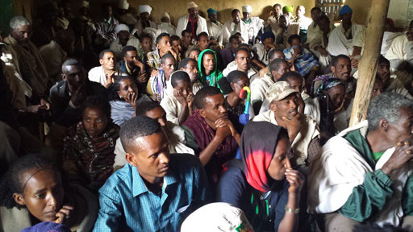

***Figure 7 Community mobilisation meeting.***

Effective community mobilisation requires consensus among key stakeholders, including community organisations and leaders. It should aim to involve all the community including religious groups, opinion leaders, schools, and marginalised groups (Open University, 2018).

The objectives of community mobilisation (adapted from WHO, 2006) are to:

* alert the community to their needs and rights
* encourage the community to be proactive, rather than passive
* develop awareness of the importance of sustainability of WASH facilities
* build the capacity of the community to take on decision making and self-management roles
* identify all the needs of the community and explore the resources available in the locality
* strengthen community participation .

**Benefits of community mobilisation**

Communities have an extensive wealth of local knowledge and wisdom. WASH practitioners should make use of this wider community experience and insight when implementing specific WASH initiatives, together with their own knowledge and understanding of procedures. Working together can help to identify what works for the community and what does not, and why (Open University, 2018)..

Analysis of urban WASH problems and addressing critical gaps can only be achieved by building on the community’s knowledge and beliefs through a continuous dialogue and not by dictating to them what they should do. Participatory engagement is crucial (Open University, 2018).

Through community involvement, ordinary urban residents and professionals study WASH problems, pool their knowledge and experience and develop ways of solving their WASH problems. Community mobilisation helps leverage the resources available for specific WASH interventions, promotes self-help and self-reliance and improves trust and partnership between WASH practitioners and the community. As an urban WASH practitioner your role is to help the community organise themselves and contribute to the success of urban WASH interventions (Open University, 2018)..

Community mobilisation can bring the following benefits (adapted from Mercy Corps, n.d., Florida DoH, n.d.). For example, it:

* allows people to make their own decisions about things that affect them
* expands inclusion of often marginalised groups, such as women, youth, people with disabilities, the elderly, and religious or ethnic minorities
* makes use of local resources, both human and material
* ensures local ownership of the issues and enables communities to create local solutions to local problems, which improves sustainability (Open University, 2018)..

There can also be other longer-term benefits. For example, communities can reduce their dependence on outside aid because they develop the ability to identify and solve their own problems. They can also be better prepared for responding to disasters and emergencies because they have experience in quickly identifying their needs and priorities, and have established relationships with decision makers.

**Strategies for community mobilisation**

Much research has been done on good practice in community mobilisation and the evidence for effective strategies tends to come from these studies and experiences. They show that community mobilisation can change attitudes, norms, practices and individual behaviours (Pact Tanzania, 2006). Figure 8 shows a community mobilisation process in which a demonstration of effective handwashing practice is taking place (Open University, 2018).

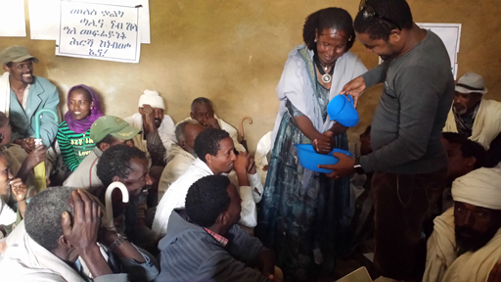

*Figure 11.2 Community demonstration of critical moments of handwashing.*

Community mobilisation is not a task for one person working on their own. It needs a team of people each with different roles who work collaboratively with the community. The team needs to include technical support staff and people with skills in project management as well as the key facilitators who have the main role of liaising with the community (Open University, 2018).

Developing a strategy for community mobilisation to address a particular problem requires:

* knowing your community and understanding the local situation
* identifying the purpose for mobilising the community – this requires understanding of the community’s goals
* assessing the issues and identifying possible projects – this needs skills to assess the problems and align them to the purpose of the community mobilisation
* obtaining wide community support – it is essential to build good relationships with individuals and groups within the community; it is very important that the facilitator has excellent communication skills
* prioritising projects and developing implementation plans
* pooling of available resources, including labour
* gathering and reflecting on feedback from the community
* refining and improving activities, based on the findings and feedback from the community (Open University, 2018).

**Knowing your community**

To mobilise your local community effectively, you need know about its social organisation, economy, problems and politics. This information can be obtained from many sources, both formal and informal, and might include (Pact Tanzania, 2006):

* political and administrative structure
* demographic features and population characteristics (e.g. number of people in different age groups, gender balance)
* economic activities (e.g. employment, market days)
* social stratification and economic status of households
* organisations, their functions and activities
* leadership pattern and its influence
* languages and cultural traditions
* health, sanitation and nutrition levels
* education levels.

Through stakeholder mapping (as described Study Session 4) you will begin to understand the nature of your community as a social system. Think about how the different elements of the community such as the children, women, youth and local organisations are connected to each other. You will soon realise that a community is not merely a collection of individuals but a system that involves a lot of intricate links and relationships between those individuals. People enter and leave the community, by birth, death and migration, so it is constantly changing and yet it continues to exist (Open University, 2018).

Getting to know your community is not something that can be achieved quickly. You will need time to develop relationships with the community members. For successful community mobilisation you need to know what will motivate people to become involved and this requires understanding of their interests and concerns (Open University, 2018).

Stakeholder mapping will also help to identify the key stakeholders in WASH and especially those who are the existing leaders within the community. Working with existing leaders is much more likely to be successful because other community members will be influenced by them and follow their lead (Mercy Corps, 2013).

**Reference**

Adams, W M. 2006. *The Future of Sustainability: Re-thinking Environment and Development in the Twenty-first Century*. Report IUCN. Available from: <http://cmsdata.iucn.org/downloads/iucn_future_of_sustanability.pdf>

Association for Project Management. 2006. ‘APM supports sustainability outlooks’. Available from: <http://www.apm.org.uk/page.asp?categoryID=4>.

Barbier, E. 1987. ‘The concept of sustainable economic development’. *Environmental Conservation* 14 (2): 101–110.

Briassoulis, H. 2001. ‘Sustainable development and its indicators: Through a (planner’s) glass darkly’. *Journal of Environmental Planning and Management* 44 (3): 27–409

Brown, H S; Jong, M de; Levy, D L. 2009. ‘Building institutions based on information disclosure: Lessons from GRI’s sustainability reporting’. *Journal of Cleaner Production*17: 571–580.

Carson, R. 1962. *Silent Spring*. Boston: Houghton Mifflin.

Coase, R H. 1960. ‘The problem of social cost’. *Journal of Law and Economics* 3: 1–44.

Dyllick, T; Hockerts, K. 2002. ‘Beyond the business case for corporate sustainability’. *Business Strategy and the Environment* 11: 130–141.

Elkington, J. 1997. *Cannibals with Forks: The Triple Bottom Line of 21st Century Business*. Oxford: Capstone Publishing Ltd.

Gareis, R; Huemann, M; Martinuzzi, A. 2009. *Relating Sustainable Development and Project Management*. Berlin: IRNOP IX.

Gilbert, R; Stevenson, D; Girardet, H; Stern, R, eds. 1996. *Making Cities Work: The Role of Local Authorities in the Urban Environment*. London: Earthscan Publications Ltd.

Global Reporting Initiative (GRI). 2009. Accessed September 2009. Available from: <http://www.globalreporting.org/NewsEventsPress/PressResources/PressRelease_14_July_2006_1000GRIReports.htm> 21.

International Institute for Sustainable Development (IISD). 2010. Accessed September 2010. Available from: <http://www.iisd.org/sd/>

Hedstrom G; Poltorzycki S; Stroh P. 1998. ‘Sustainable development: The next generation’. *Prism* 4: 5–20.

Holliday C. 2001. ‘Sustainable growth, the DuPont way’. *Harvard Business Review* September: 129–134.

International Project Management Association. 2006. *IPMA Competence Baseline version 3.0*. Nijkerk, the Netherlands: IPMA,

Keating, M. 1993. *The Earth Summit’s Agenda for Change*. Geneva: Centre for our Common Future.

Labuschagne, C; Brent, A C. 2006. ‘Social indicators for sustainable project and technology life cycle management in the process industry’. *International Journal of Life Cycle Assessment* 11 (1): 3–15.

Lydia Guy Ortiz. (2011). Community MobilizatioN and Primary Prevention. Available online at [http://learn.preventconnect.org/pluginfile.php/397/mod_resource/content/1/Community-Mobilization.pdf ].

McKinlay, M. 2008. ‘Where is project management running to?’ Key-note speech, International Project Management Association, World Congress, Rome, Italy.

Moneva, J M; Archel, P; Correa, C. 2006. ‘GRI and the camouflaging of corporate sustainability’. *Accounting Forum* 30: 121–137.

Niemeijer, D; de Groot, R S. 2008. ‘A conceptual framework for selecting environmental indicator sets’. *Ecological indicators* 8: 14–25

OECD. 1990. *Issues papers: On Integrating Environment and Economics*. Paris: OECD.

Pope, J; Annandale, D; Morris-Saunders, A. 2004. ‘Conceptualising sustainable assessment’. *Environmental Impact Assessment Review* 24: 595–616.

PriceWaterhouseCoopers. 2009. *Sustainability Monitor (In Dutch:*

*Duurzaamheidsbarometer), May 2009, measurement 4*. Amsterdam: PriceWaterhouseCoopers.

Project Management Institute. 2008. *A Guide to Project Management Body of Knowledge (PMBOK Guide)*. 4th edn. Newtown Square, PA USA: Project Management Institute.

Russell, J. 2008 ‘Corporate social responsibility: What it means for the project manager’. In Proceedings of PMI Europe Congress, Malta, Philadelphia, PA: Project Management Institute

Silvius, A J G; Batenburg, R. 2009. ‘Future development of project management competences’. Paper presented at the 42nd Hawaii International Conference on Systems Science (HICSS), Waikoloa HI, January 2009.

Silvius, A J G; Brink, J. van der; Köhler, A. 2009. ‘Views on sustainable project management’. In *Human Side of Projects in Modern Business*, edited by Kähköhnen, Kalle; Kazi, Abdul Samad; Rekola, Mirkka. Helsinki, Finland: IPMA Scientific Research Paper Series.

Silvius, A J G; Brink, J. van der; Köhler, A. 2010. ‘The concept of sustainability and its application to project management’. Paper presented at IPMA Expert Seminar Survival and Sustainability as Challenges for Projects, Zurich.

Singh, R K; Murty, H R; Gupta, S K; Dikshit, A K. 2009. ‘An overview of sustainability assessment methodologies’. *Ecological Indicators* 9: 189–212.

Taylor, T. 2008. *A Sustainability Checklist for Managers of Projects*. Available from: <http://www.pmforum.org/library/papers/2008/PDFs/Taylor-1-08.pdf>.

Thomas, G; Fernandez, W. 2007. ‘The elusive target of IT project success’. International Research Workshop on IT Project Management (IRWITPM), Association of Information Systems, Special Interest Group for Information Technology Project Management, Montreal, December 9–12.

Turnhout, E; Hisschemoller, M; Eijsackers, H. 2007. ‘Ecological indicators: Between the two fires of science and policy’. *Ecological indicators* 7: 215–228.

Turner, R; Huemann, M. 2010. ‘Responsibilities for sustainable development in project and program management’. IPMA Expert Seminar Survival and Sustainability as Challenges for Projects, Zurich.

World Commission on Environment and Development. 1987. *Our Common Future*. Great Britain: Oxford University Press.

|  |  |
| --- | --- |
|  |  |